Capstone Project:

Kennerly Construction Web Application

5-Star Development

Arkansas Tech University

TABLE OF CONTENTS

System Documentation 3

Introduction 3

Development Team 3

Project Details 3

System Analysis 4

UML/DFD Diagrams 4

Diagram Analysis 4

ER Model 4

ER Model Analysis 4

Execution/Explanation Process 4

System Design 5

Homepage 5

Payment Page 6

Apply for Job 6

Contact Company 7

Employee Login 7

Databases 8

Job Table 8

Vehicle Table 9

Site Map 9

Site Map Analysis 9

System Implementation 10

Code Development 10

Code Analysis 10

Nav Bar/CSS Analysis 10

Conclusion 11

Client Signatures 12

System Documentation

**Introduction**

This system was created for Kennerly Construction with the main function of streamlining business processes due to large business growth in recent years. Kennerly Construction is based in Malvern, Arkansas. Their main area of work is trucking. Due to increased growth, the company has acquired a variety of trucks and vans, which need to be maintained on a regular basis. To maintain proper records, the company has requested our team to design a website with database access that would let the company keep up with records. In addition, the company requested a payment method to be implemented along with access to an employment application for prospect employees to use and apply in a quick manner. Our team developed this system to fulfill the business’ needs. This document will explain the processes and applications that were used to make this system usable to the company.

**Development Team**

Our team, 5-Star Development, is formed by the following team members:

* Jefferson Stinson – Project manager
* Camron Stewart – Front end designer
* Jackson Sheesley – Advisor
* William Barrientos – Coordinator
* Alex Niedzwiedz – Resource manager

**Project Details**

* 1-18-2021 – Project started.
* 1-21-2021 – Proposal approved.
* 1-30-2021 – Requirements list created.
* 2-8-2021 – Preliminary site mockups created.
* 2-16-2021 – Mockups accepted by business.
* 2- 24-2021 – Payment method created and approved by business.
* 3-8-2021 – Website draft created, and databases tested.
* 3-16-2021 – Project progress shown to business.
* 4-3-2021 – Project put together, ready to be polished.
* 4-16-2021 – Final touches put together.
* 4-22-2021 – Final system presented.

**System Analysis**

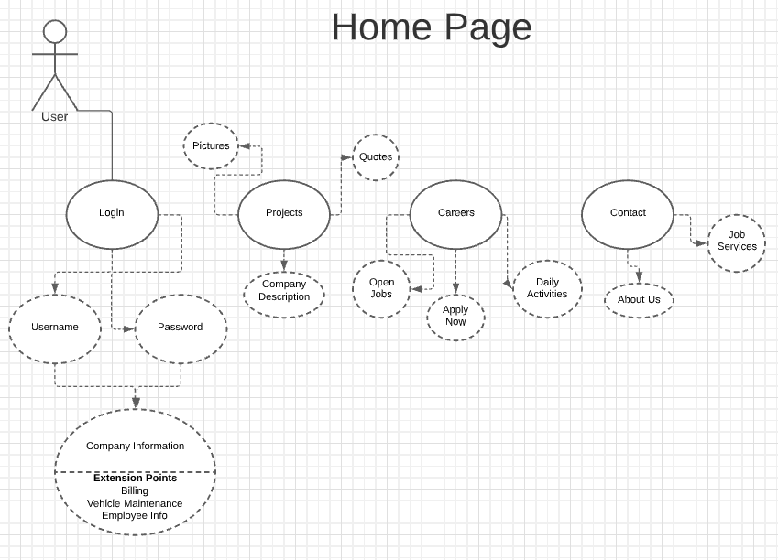

* Diagram shows how the user interacts with the website and how the corresponding databases and back-end code allow gateways to other resources.
* If a user is authorized in the system the server will allow the user to access a private database that has company employee info, billing, and vehicle maintenance information.
* When a user interacts with a navigation tab it will give access to the corresponding webpage that contains connected data and company information.

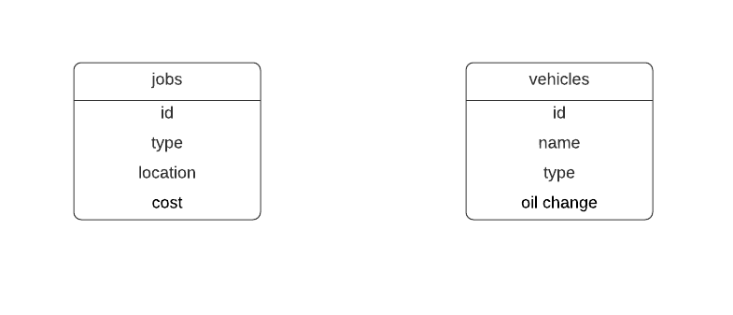

* The ER model was a split between two separate databases between company projects and vehicle maintenance.
* The projects database had a table named jobs, the jobs table had job_id, job_type, job_location, and job_cost entities.
* The vehicles database had a table named vehicles, the vehicles table had vehicle_id, vehicle_name, vehicle_type, and vehicle_oil entities.
* Each database was created to help maintain and organize billing for the company’s projects and vehicle maintenances. This was done to modernize the billing system as they currently use mail.

We built the analysis models based on the company’s needs and requests. We built the data flow diagram to give a visual representation for how we wanted the front-end and back-end code to work together. It helped give the team and clients an idea of how the website would be interact with by a user and an authorized user. The goal was to have a functioning website that gave users ease of navigation and had important information about the company displayed. The ER model was modeled after the two separate databases the team created. One database was connected to the company’s projects and billing to help organize that information for the client. Another separate database was implemented to split up the billing information between vehicle maintenance and projects. The vehicle database is used to keep records of previous changes to vehicles or to help with warranties on their equipment.

**System Design**

* Include and explain UI

Home page

Payment page

Apply for a job

Contact the company

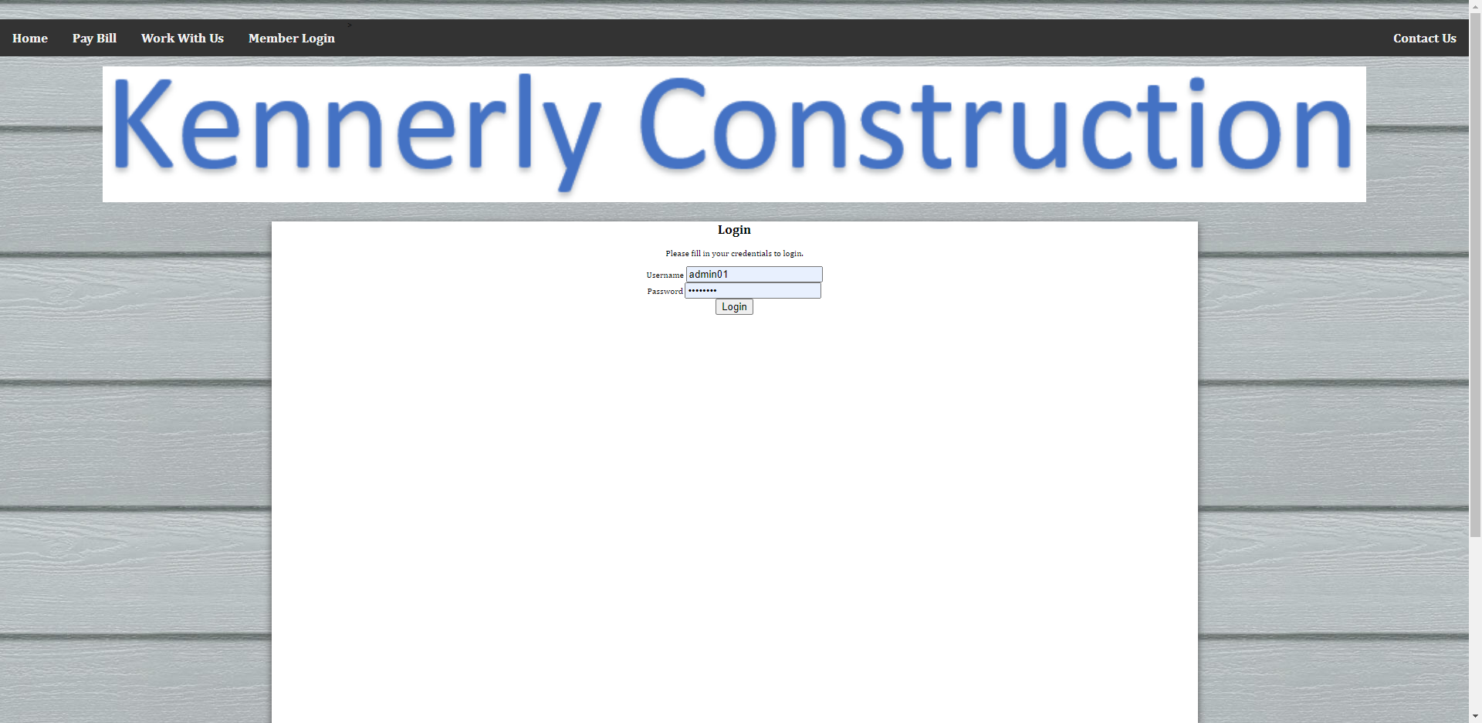

Employee login

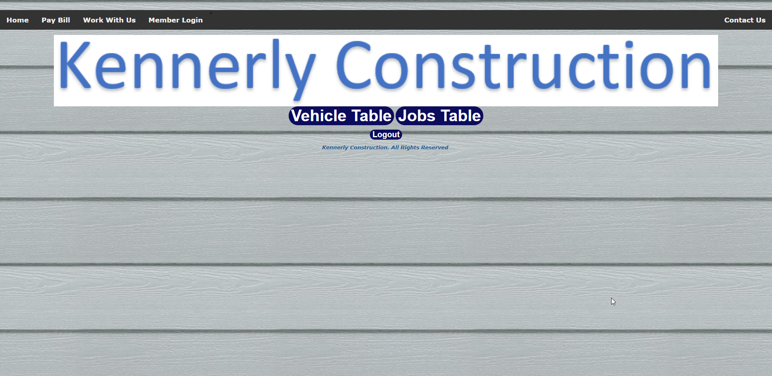

Pick which table you want to interact with

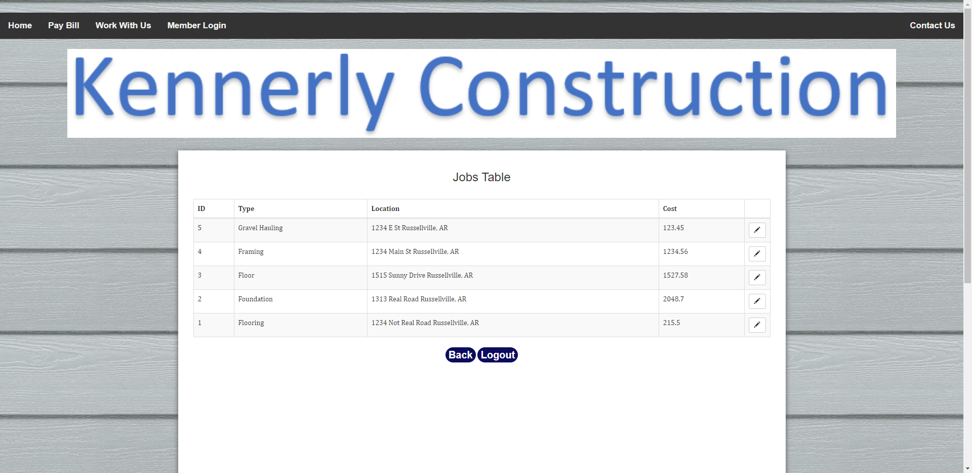

Job table

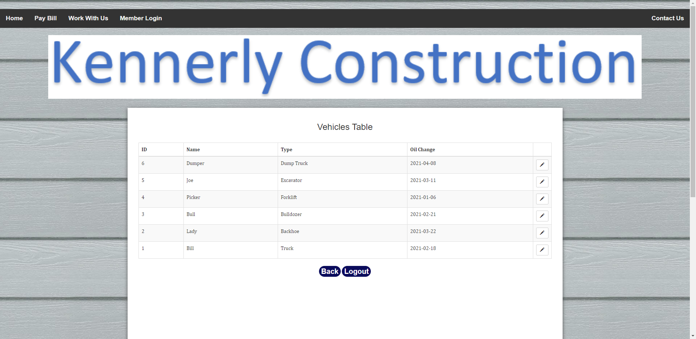

Vehicle table

The UI is mostly coded in HTML and JavaScript. We tried to make the website look professional while being simple to use. The slideshow on the home page can easily be modify, so if the client wants to switch, delete, or add a picture they can. We wanted to have the buttons on top to be clear on where they will take the user and to be in same location on all pages.

* Include and explain sitemaps

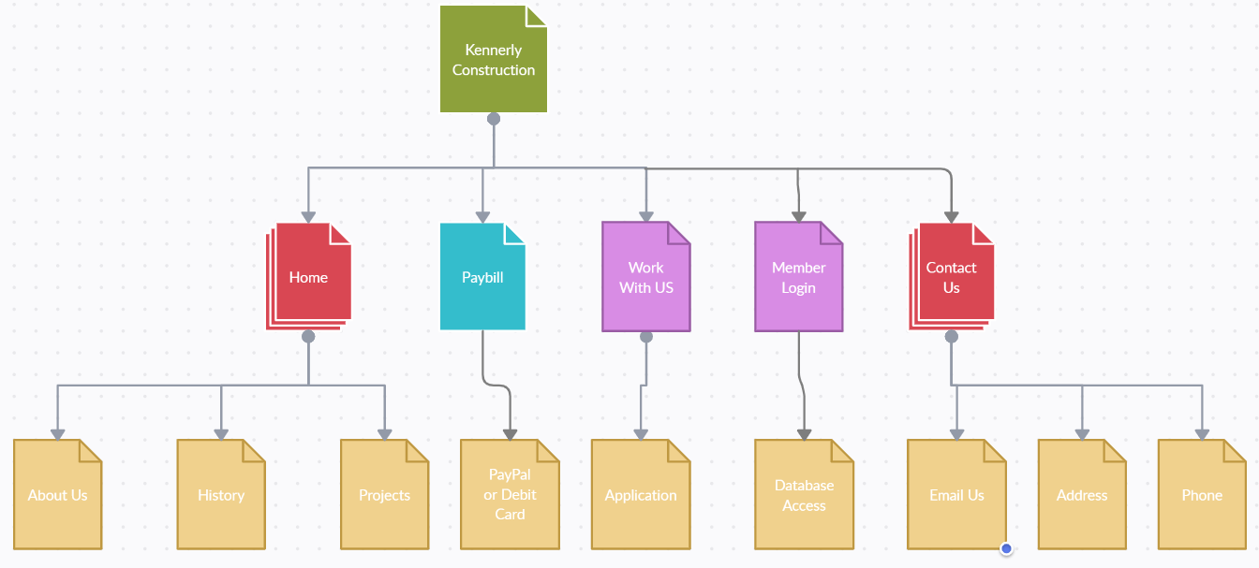

Keeping the same trend as the UI, we wanted it to be simple. The user will be brought to the Kennerly Construction page / home page. Each of the buttons on top will bring the user to that page (ex: Pay Bill button will bring the user to paypal or debit card page).

**System Implementation**

The system we created was a website that must be hosted with a service that can connect the php and mysql. We used a service called Wampserver that will do that for you and host the site on your local network. It was wrote in php, html, and mysql with a bit of scripts too.

* Code: <https://drive.google.com/drive/folders/10kSIfg4t-JlKv3eslj21Unw_l-8N9jW6?usp=sharing>
* Wampserver: <https://sourceforge.net/projects/wampserver/>

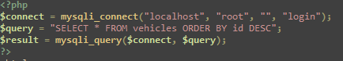

This is the php connecting to the server localhost, with the username root, password is blank for testing, and the database is called login. Then it selects all from the table called vehicles.

To make the table editable I use a file called action.php and action2.php which changes the database by generating mysql code form what you input and changed. It lines up the rows by their id, which you cannot change, so that you are changing the correct one. 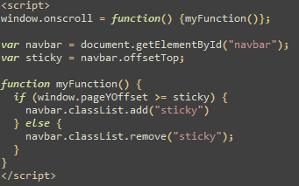

This script is what we have to make the navbar scroll down when you do to make sure it is always available. This makes the site look a bit more modern, which if we had more time, we could have worked a lot more on that.

**Conclusion**

Throughout this project we accomplished a complete website with some graphically pleasant features. We also made a payment system and attached two databases that included listing of job the company is doing and vehicles that they have. We included a form to provide information if you wished to apply for a job with a total of five tabs, some other inclusions were a slide of photos to show some of the business and about info, as well as contact information. Over the course of this project, we learned teamwork and time management skill as well as technical skills that pertain to database management and linkage. We overcame the obstacle of separation due to covid-19 and figured out how to delegate work and combine the separate code into one final project. We have learned a lot getting to work with this company and building this product and our looking to apply the real-world practice in the future.

**This document which serves as a partial requirement of the department capstone project ……. has been read and approved by:**

Kyle Kennerly Kyle Kennerly

Person 1 Date: 04-26-2021  
Title: Co-Owner  
Company: Kennerly Construction, Inc

Greg Kennerly Greg Kennerly

Person 2 Date: 04-26-2021  
Title: Owner  
Company: Kennerly Construction, Inc

Cindy Kennerly Cindy Kennerly

Person 3 Date: 04-26-2021  
Title: Front-End Supervisor/Manager  
Company: Kennerly Construction, Inc